Functional requirements

1. **Required functionality**

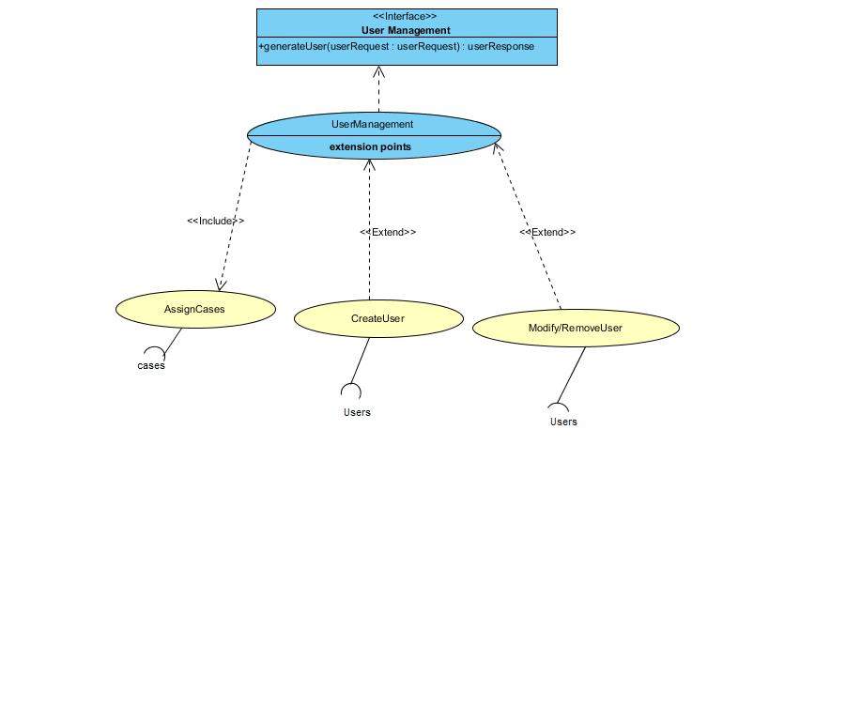

Figure UserManagement

a) User management

- The user management assign cases, create cases, modify and remove users.

b) Case Management

c) Reporting

1. **Domain objects(5.6)**
   * 1. Overview

The main domain objects are

Persons – This may be assigned forensic officers, forensic practitioner, administrator and students with respect to different responsibilities and access level.

Cases - it can be aggregated into different type of scenes and different type of cases (e.g. natural and un-natural)

User management – adding users and gives them different responsibilities.

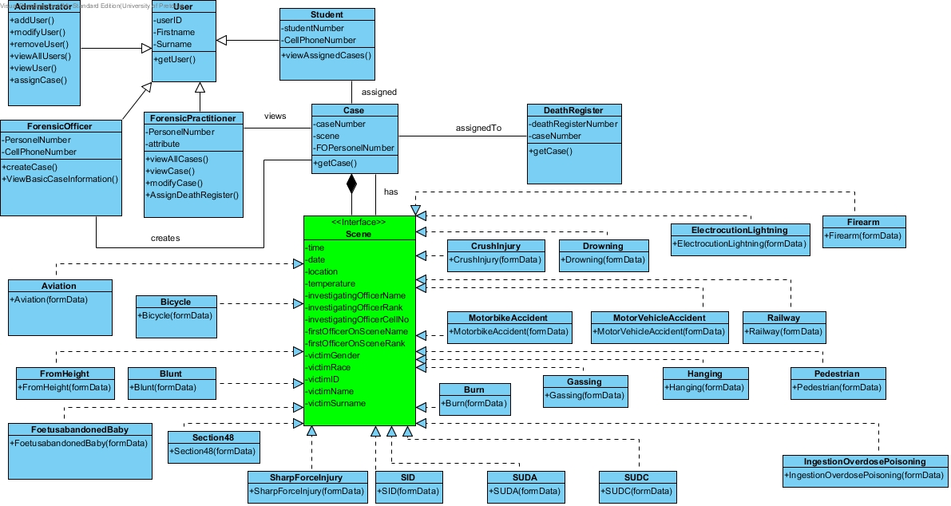

Figure overview of data structures and relationships for the core domain

* + 1. Persons

All users are going to be registered in the database and authentication will be done against the database.

The registered user’s information will include the name, surname, portfolio and its details, roles and responsibility, personnel ID and access rights.

The user class will be identified by a unique role of a user.

* + 1. Cases

Cases can be either natural or un-natural. Forensic officer can decide whether the case is natural or un-natural. And for unnatural case, every case will be assigned a different death registry and will be stored in a special registry of un-natural cases.

Every case has a scene and scenes are divided as follows:

* Sudden and unexpected death
  + Sudden unexpected death of an infant (SUDI)
  + Sudden unexpected death of a child (1 – 18 years)
  + Sudden unexpected death of an adult/ found dead
* Foetus / Abandoned baby
* Section 48 death –surgical case
* Road traffic accidents
  + Pedestrian vehicle accident
  + Bicycle accident
  + Motorbike accident
  + Motor vehicle accident
* Railway accident
* Aviation accident
* Fall/push/jump from height
* Crush injury
* Firearm discharge/ gunshot wound
* Sharp force injury/ stab injury
* Blunt force injury/ assault
* Drowning
* Gassing
* Hanging
* Ingestion/overdose /poisoning
* Burns
* Lightning/ electrocution
  + 1. User management

The administrator will be able to add, remove and edit the users in the system. Every change that is made will be recorded in the audit log. The administrator should also be able to assign cases to user in the system e.g. assign 50 students to a hanging case for research.

1. **Use case prioritization**
   1. Login(critical)

All the system functionality should be accessible by users who are logged in.

* 1. Case management(critical)

The system should be able to create a case, modify, view and assign a death register number; because this is the main reasons the system exists.

* 1. User management(important )

The system must be able to allow only specific users to view specific information, this will ensure that the system is secured and privacy is maintained.

* 1. Reporting

It will be useful for accountability for accountability and auditability.

1. **Use case/services contracts**

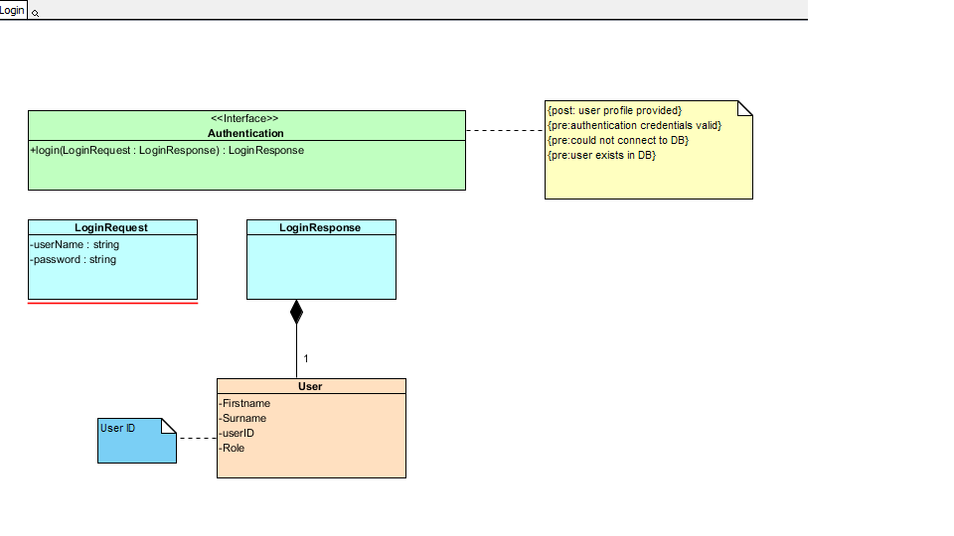

Figure Login service contract

1. **Process specification**

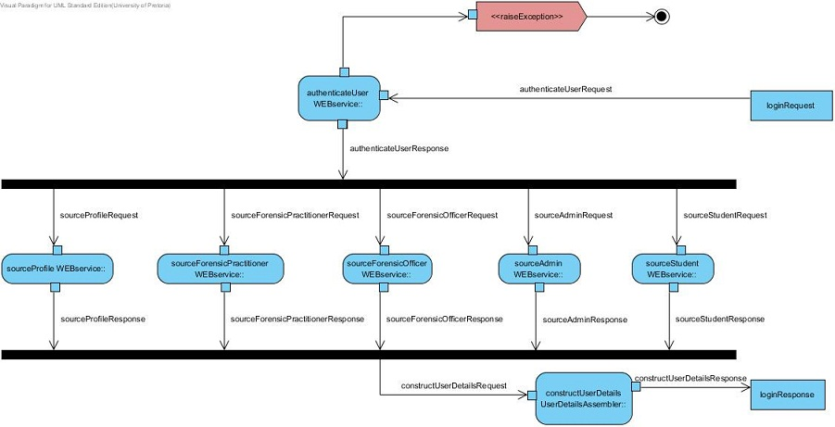

Figure login activity diagram

Figure Reporting

1. **Domain Objects**